Build Your Measurement Plan
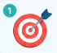
What is your improvement AIM?
__________________________________________________________________________

What outcome measure will you collect?
____________________________________________________________________________
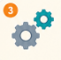
What process measure will you collect?
___________________________________________________________________________
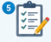
How will you collect the data?
____________________________________________________________________________
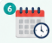
When will you collect the data?
___________________________________________________________________________

